CyberArk PIM

# PSMP Installation

Version 10.4

|  |  |
| --- | --- |
| **Document Owner** | |
| Author | Title / Position / Responsibility |
|  |  |

|  |  |  |  |
| --- | --- | --- | --- |
| **Change History** | | | |
| Version | Date Changed | Modified By | Nature of Amendment |
| 1.0 |  |  |  |
|  |  |  |  |
|  |  |  |  |
|  |  |  |  |

|  |  |  |  |
| --- | --- | --- | --- |
| **Approval** | | | |
| Version | Approved Date | Approved By | Comments |
|  |  |  |  |
|  |  |  |  |
|  |  |  |  |
|  |  |  |  |

Table of Contents

1. Pre-Installation

1.1 Pre-requisite check

2. Installation

3. Post Installation Task

## 1. Pre-Installation

Make sure vault is pingable from the psmp server.

1. Copy the PSMP folder to the REDHAT server.
2. In the PSMP folder there are following files

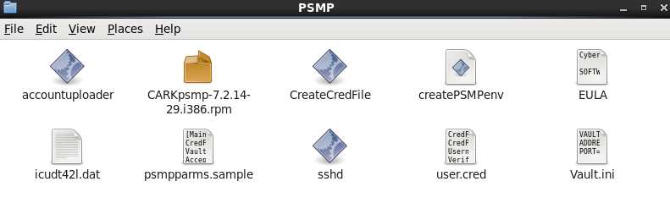

1. Open the Vault.ini file

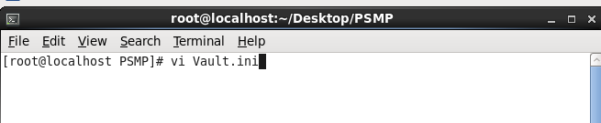

1. Go into insert mode by pressing “i” key.
2. Change the name of vault server name and its IP Address x.x.x.x.x.x.x.x

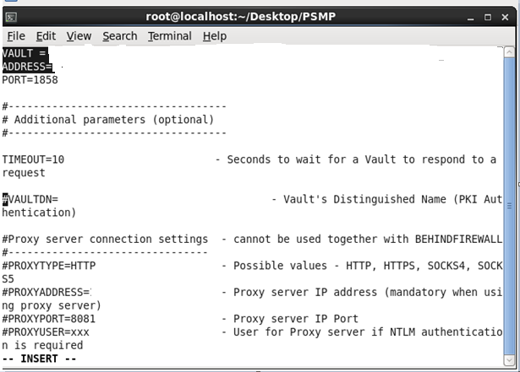

1. Press ESC key to exit from insert mode.
2. Save by pressing :wq (quit and save).
3. Now we have to create cred file for creating vault environment for PSMP for that we use CreateCredFile utility.
4. Open terminal and type ./CreateCredFile user.cred

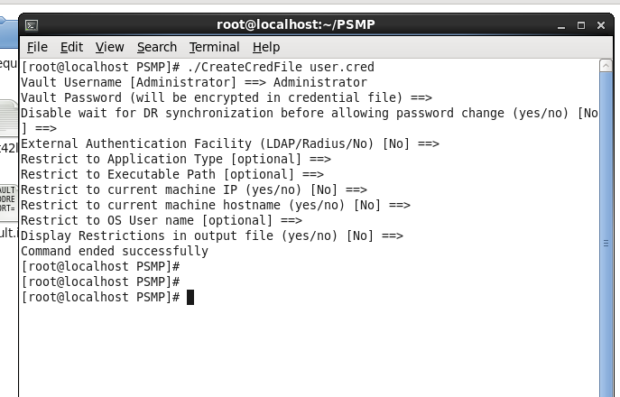

1. Now copy the parameter file psmpparms.sample to /var/tmp by the name psmpparms.

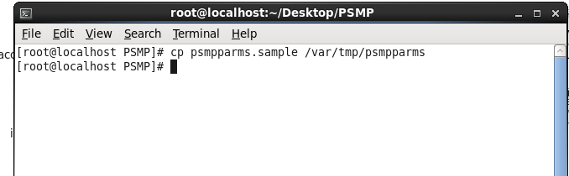

1. Now go to /var/tmp and open psmpparms file and type vi psmpparms to edit the file.

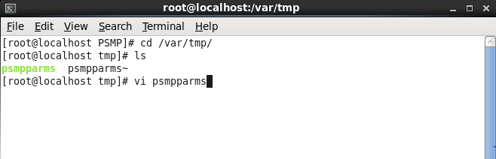

1. Press “i” and go to insert mode.
2. Edit the file with following changes-
3. Enter the path of cred file that we created in step-9 i.e. “user.cred”.
4. Enter the path of vault.ini file that we edited in step-5
5. Change AcceptCyberArkEula=Yes.
6. Change PSMPAppUser=PSMPApp
7. Change PSMPGWUser=PSMPGW
8. Change ADBridgeUser=PSMP_ADB

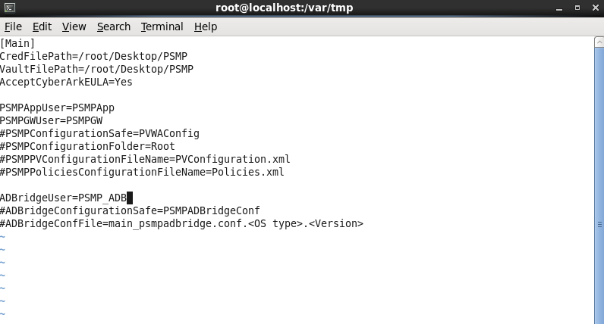

1. Save by pressing :wq (quit and save)

**2**. **Install the PSMP**

2.1 Run the PSMP installer using command rpm – i CARKpsmp-…….

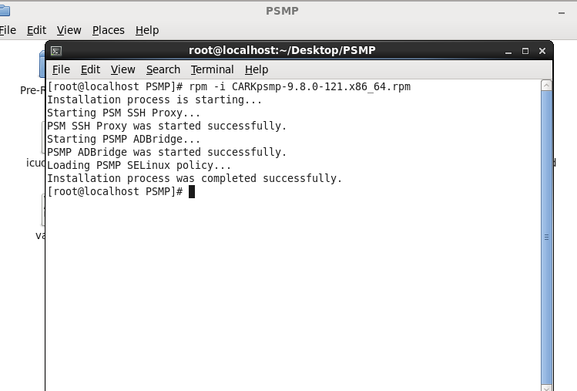

2.2 Check the logs in /var/tmp for any error or successful installation.

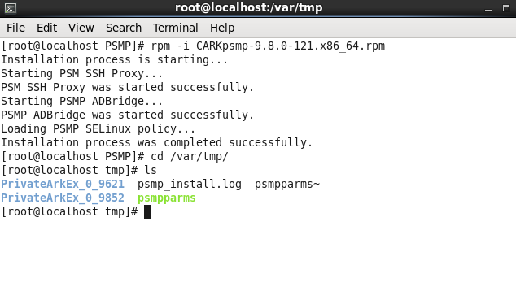

###### 2.3 Psmp_install.log is the log file of PSMP.

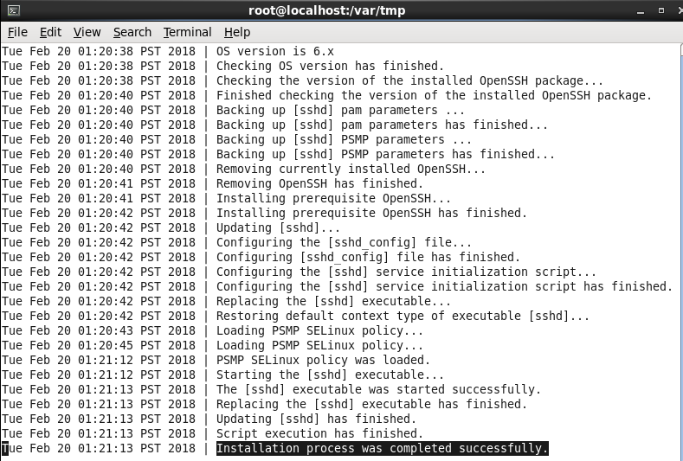

Here we can see the line that says Installation process was completed successfully and here our PSMP is installed.

**3. Post-installation Tasks**

3.1 The following topic describes tasks that may need to be performed following the PSMP

Installation.

After the PSMP has been installed successfully, it will be started automatically. Use the

Following commands or log files to verify that the PSMP services are running.

|  |  |
| --- | --- |
| **Platform/File** | **Command/Location** |
| RHEL and CentOS | /etc/rc.d/init.d/psmpsrv status |
| PSMPConsole.log | /var/opt/CARKpsmp/logs |